DATNET LTD
NETWORK DESIGN & SECURITY IMPLEMENTATION REPORT

Building a Smart Office Network & Securing Connections with ACLs

Prepared by: Abiodun Bashiru
Role: Junior Network Engineer & Cybersecurity Analyst
Date: April 10th 2026
Location: Rockwall, Texas, USA

Table of Contents
1. Executive Summary
2. Company Background
3. Network Design
4. Implementation
5. Security Configuration (ACLs)
6. Testing & Results
7. Conclusion

1. Executive Summary
This report presents the successful design and implementation of a secure multi-department network for DatNet LTD using Cisco Packet Tracer. The project demonstrates practical networking skills and security enforcement using Access Control Lists (ACLs).

2. Company Background
DatNet LTD is a data-processing company headquartered in Rockwall, Texas, specializing in secure healthcare data exchange. As the company expands, robust and secure networking infrastructure is required.

3. Network Design
The network consists of a router, switches, PCs, and a server across three departments: Admin, Sales, and HR. Each department operates on a separate subnet for segmentation and security.

4. Implementation
Devices were configured with static IP addresses and connected through switches to a central router. Connectivity was verified using ping tests and Web browser

5. Security Configuration (ACLs)
ACLs were configured to enforce security rules:
- Admin: Full access
- Sales: Limited access
- HR: Restricted access
These rules ensure sensitive data remains protected.

6. Testing & Results
Connectivity tests confirmed expected behavior. Admin maintained full access, Sales had partial access, and HR was denied access to internal resources and server services.

Figure 1
Initial network device placement in Cisco Packet Tracer.
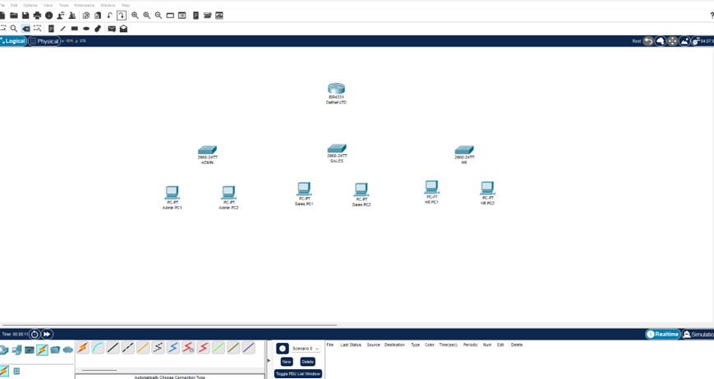

Figure 2
Network topology after cabling connections.
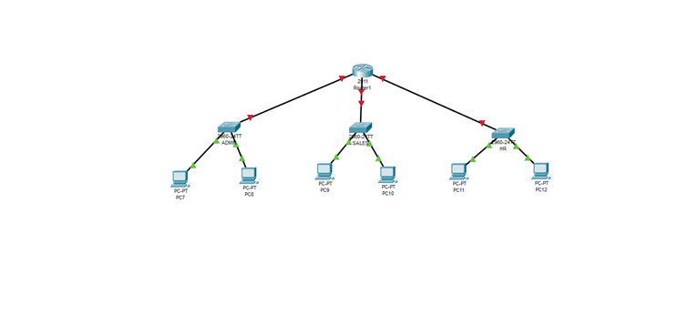

Figure 3
Admin PC IP configuration.
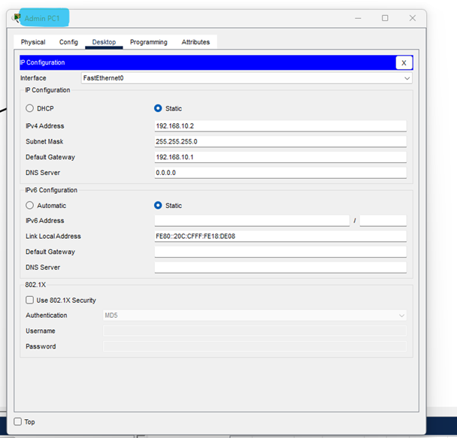

Figure 4
Sales PC IP configuration
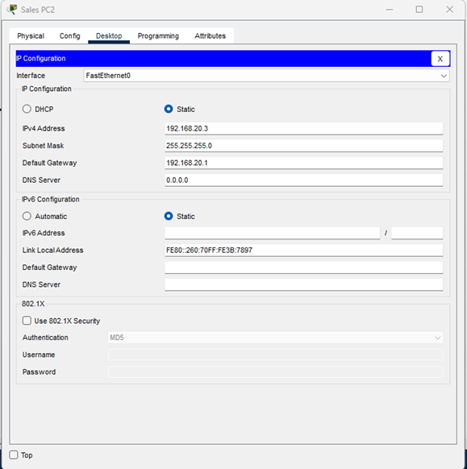

Figure 5
HR PC IP configuration
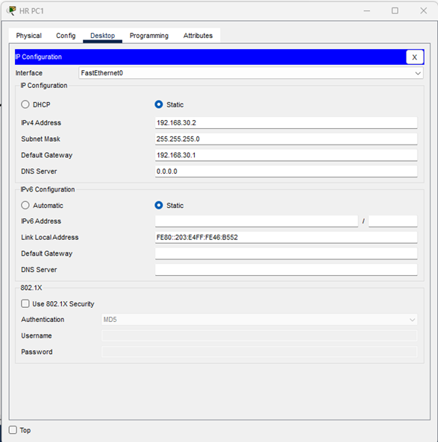

Figure 6
Router CLI configuration (interface setup).
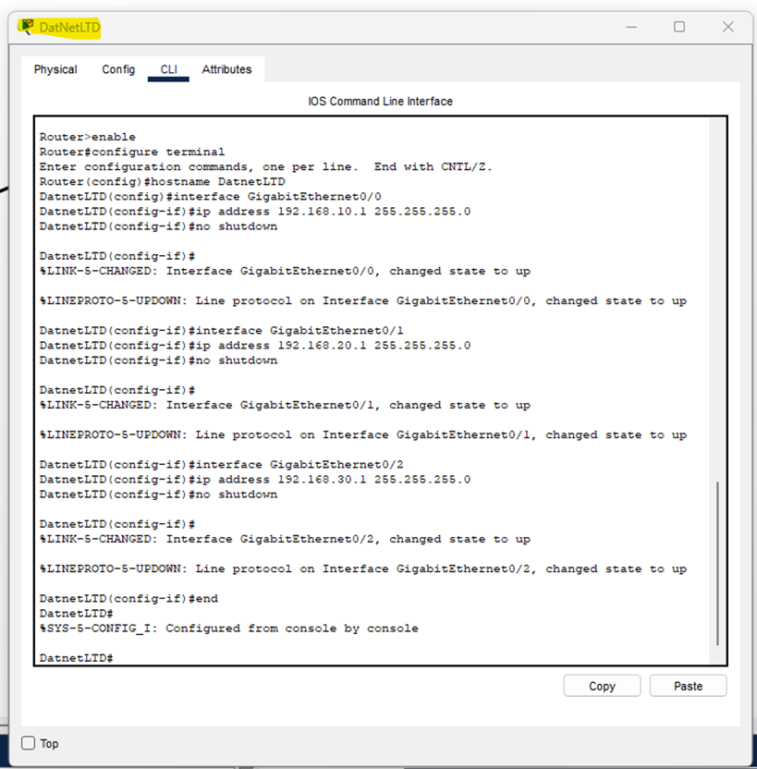

Figure 7
Network showing successful connectivity.
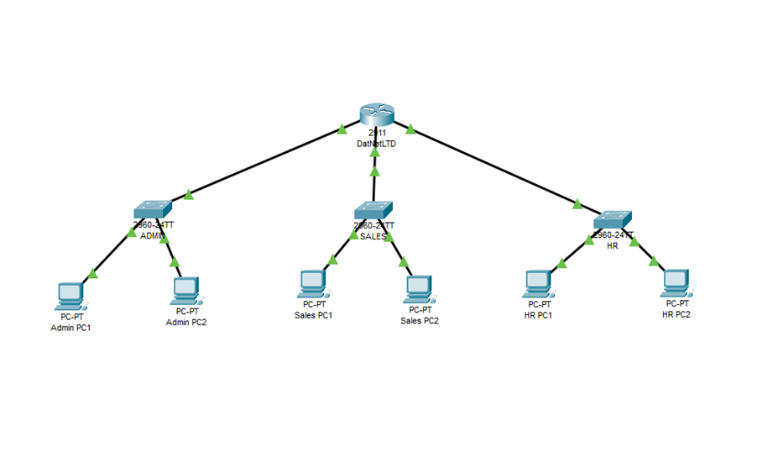

Figure 8
Admin to Admin ping test (successful).
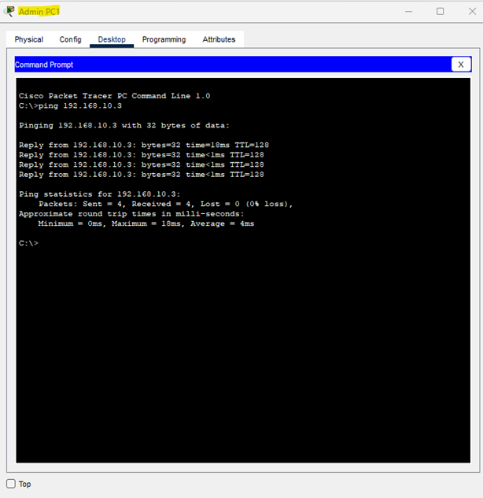

Figure 9
Admin to Sales ping test (limited).
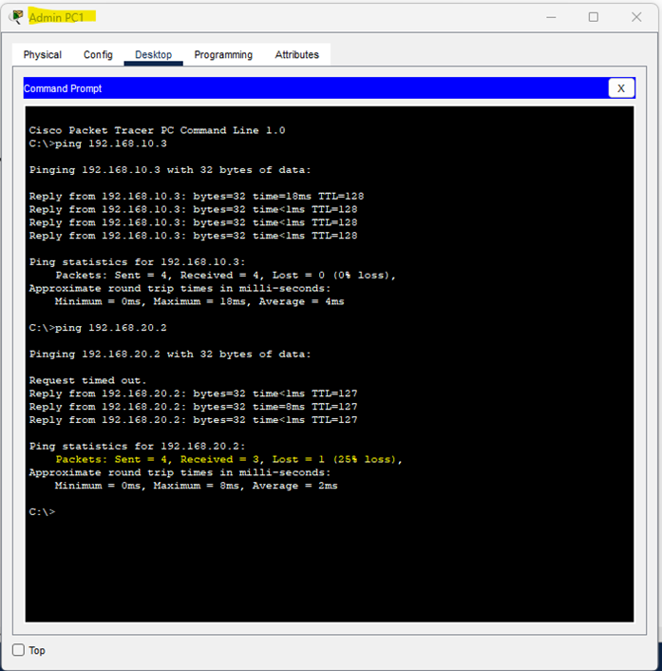

Figure 10
HR to Admin before ACL enforcement.
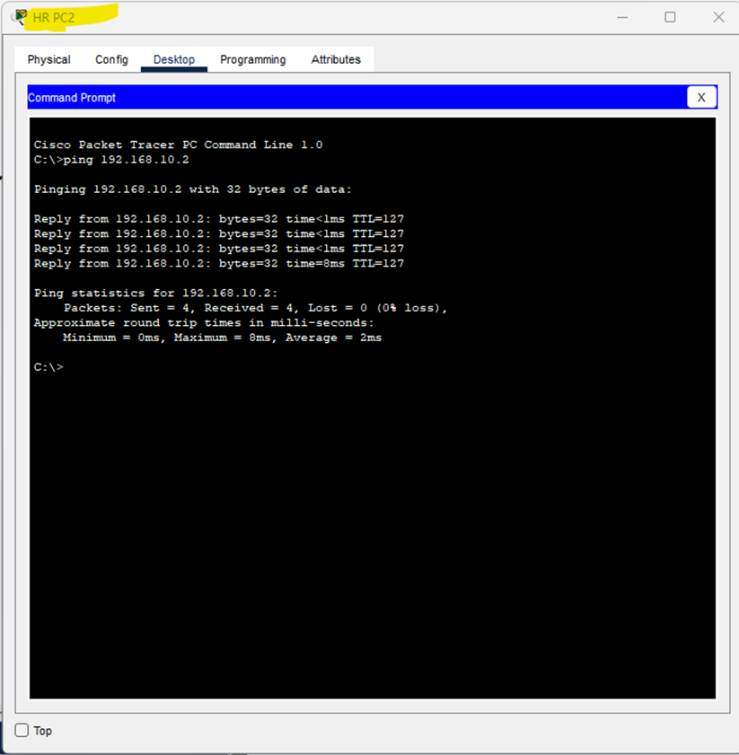

Figure 11
DHCP Relay configuration.
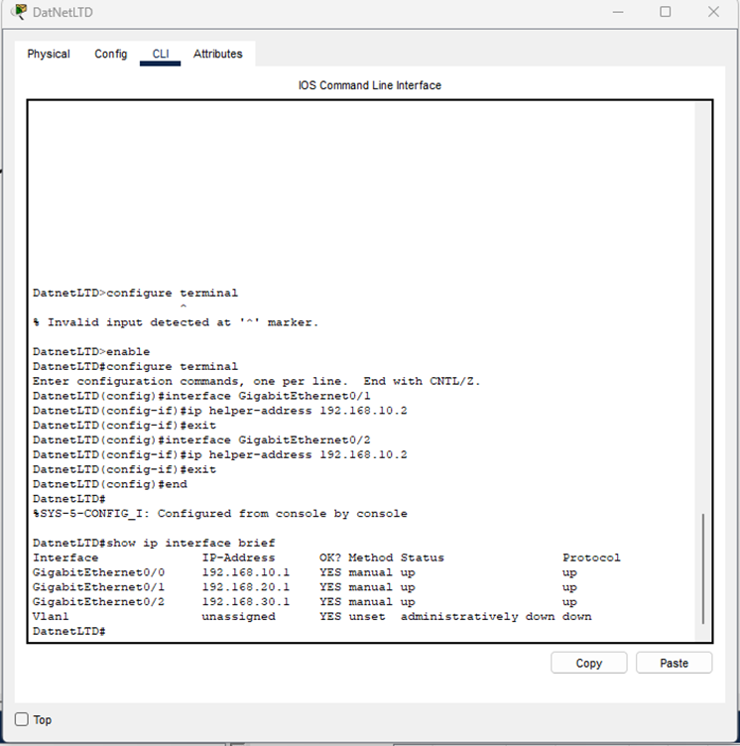

Figure 12
ACL configuration for HR network. – After I ran the access list command
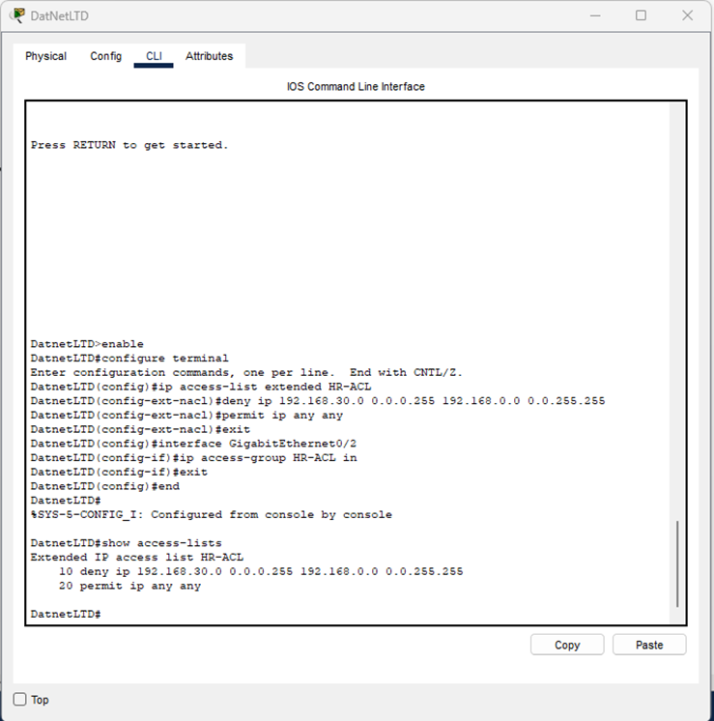

Figure 13
ACL verification output.
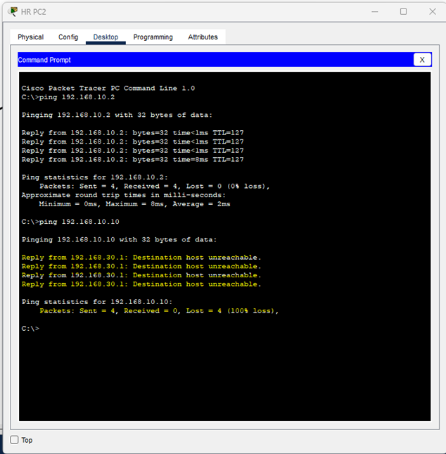

Figure 14
HR denied access to server.
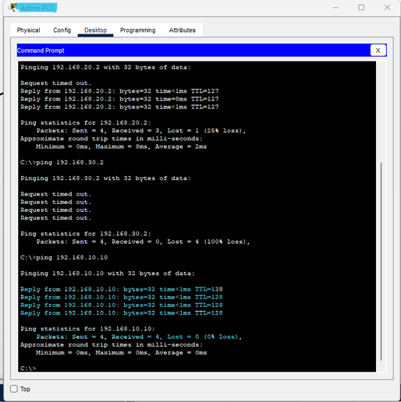

Figure 15
Sales successful Limited access to server.
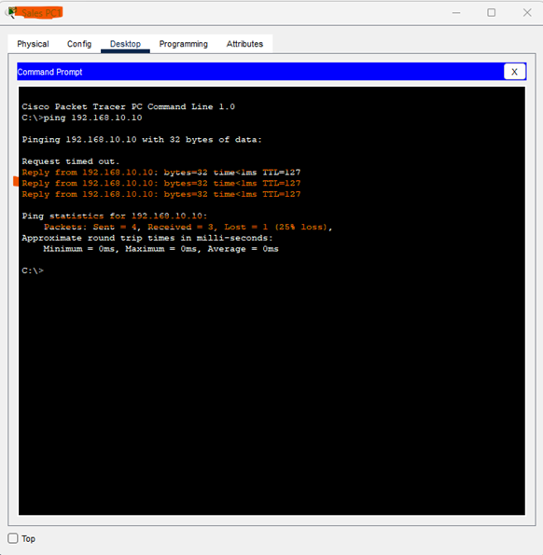

Figure 16
Server access to web.
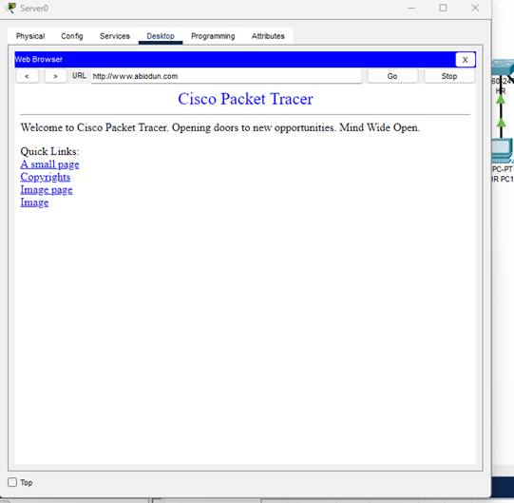

Figure 17
Successful web access from Admin.
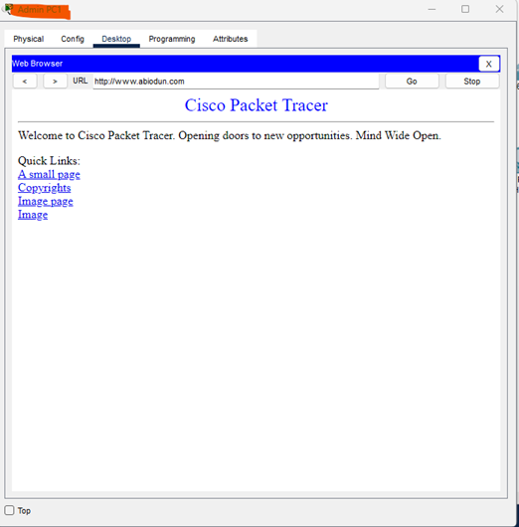

Figure 18
HR denied web access.
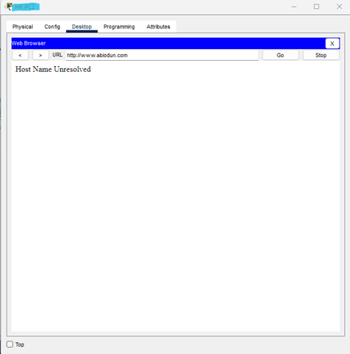

7. Conclusion
This project successfully demonstrates how ACLs can secure a network by controlling traffic between departments. It highlights best practices in network segmentation and cybersecurity implementation.

